Event Risk Assessment & Preparedness

# Club Name: Click or tap here to enter text.

|  |  |  |  |  |
| --- | --- | --- | --- | --- |
| **Location:** |  |  | Click or tap here to enter text. | **Event Date** |
| **Event Type:** |  |  | Choose an item. | Start: Click or tap to enter a date. |
| If other please describe |  |  | Click or tap here to enter text. | Finish:Click or tap to enter a date. |
| Event Coordinator: |  |  | Click or tap here to enter text. | Phone No:Click or tap here to enter text. |

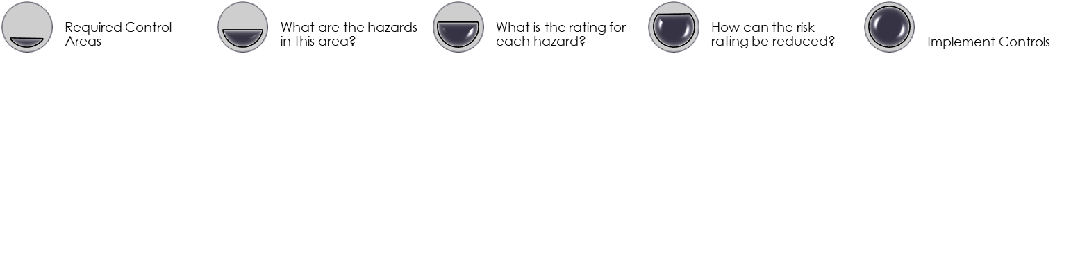

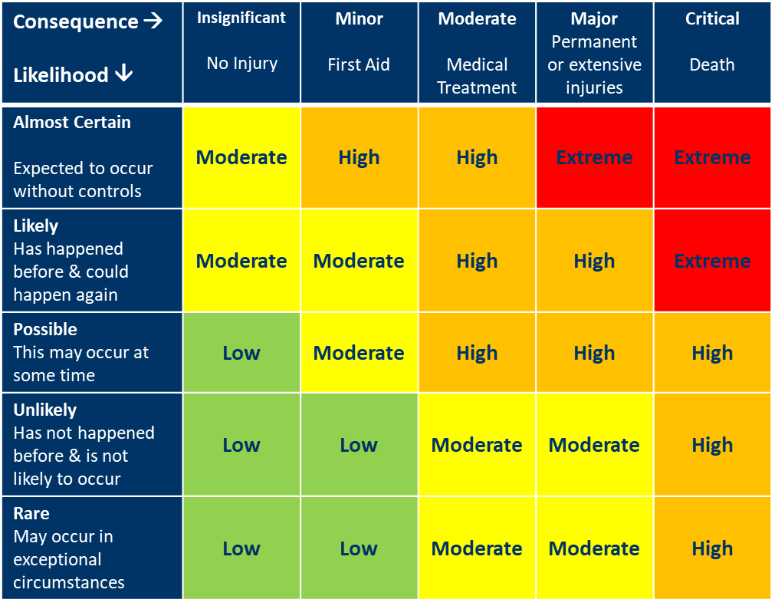

# Risk Assessment & Management Plan

Please add rows and detail to your plan to cover all hazards identified

| Hazard Source | Is this Hazard present?  (Yes/No) | What is the hazard? | Risk Rating | | Risk Management Plan A risk management plan must be completed for Risks rated High or Extreme | Implemented | Communicated | | Assessed | |
| --- | --- | --- | --- | --- | --- | --- | --- | --- | --- | --- |
| Event Management |  |  |  | |  |  |  | |  | |
| Access & Parking |  |  |  | |  |  |  | |  | |
| Gates & Access | |  |  |  |  | |  | |  | |  | |
| Roads | |  |  |  |  | |  | |  | |  | |
| Float & Overnight Parking | |  |  |  |  | |  | |  | |  | |
| Spectator Parking | |  |  |  |  | |  | |  | |  | |
| Stable Access | |  |  |  |  | |  | |  | |  | |
| Traffic Management - Vehicles | |  |  |  |  | |  | |  | |  | |
| Vehicle routes | |  |  |  |  | |  | |  | |  | |
| Speed | |  |  |  |  | |  | |  | |  | |
| Judge and official vehicles | |  |  |  |  | |  | |  | |  | |
| Traffic Management – Horses |  |  |  | |  |  |  | |  | |
| Horse Containment |  |  |  | |  |  |  | |  | |
| Horse/ vehicle crossing management |  |  |  | |  |  |  | |  | |
| Camping & Stabling |  |  |  | |  |  |  | |  | |
| Camping Areas |  |  |  | |  |  |  | |  | |
| Electricity Access |  |  |  | |  |  |  | |  | |
| Stables |  |  |  | |  |  |  | |  | |
| Spectators |  |  |  | |  |  |  | |  | |
| Biosecurity & Horse Welfare |  |  |  | |  |  |  | |  | |
| Biosecurity Hazards |  |  |  | |  |  |  | |  | |
| Wash bays & cooling |  |  |  | |  |  |  | |  | |
| Lunging areas |  |  |  | |  |  |  | |  | |
| Water availability |  |  |  | |  |  |  | |  | |
| Stallion Management |  |  |  | |  |  |  | |  | |

|  |  |  |  |  |  |  |  |
| --- | --- | --- | --- | --- | --- | --- | --- |
| Hazard Source | Is this Hazard present?  (Yes/No) | What is the Hazard? | Risk Rating?  Low  Moderate  High  Extreme | Risk Management Plan A risk management plan must be completed for Risks rated High or Extreme | Implemented | Communicated | Assessed |
| Field of Play |  |  |  |  |  |  |  |
| Surfaces and surrounds |  |  |  |  |  |  |  |
| Competition area location and condition |  |  |  |  |  |  |  |
| Warm-up location and condition |  |  |  |  |  |  |  |
| Jumps and other event equipment |  |  |  |  |  |  |  |
| Horse Hazards |  |  |  |  |  |  |  |
| Conditions or actions that could startle horses |  |  |  |  |  |  |  |
| Weather |  |  |  |  |  |  |  |
| Hot weather |  |  |  |  |  |  |  |
| Rain |  |  |  |  |  |  |  |
| Wind |  |  |  |  |  |  |  |

# Emergency Preparedness Plan

|  |  |  |
| --- | --- | --- |
| Roles and Responsibilities | Have the roles and responsibilities of the following people in managing risk at the event been documented and communicated?  (yes/ no/ NA) | Have the roles and responsibilities of the following people in responding to and managing incidents and injuries been documented and communicated  (yes/ no/ NA) |
| Officials |  |  |
| Event Organiser |  |  |
| Stewards |  |  |
| Event Committee |  |  |
| Technical Delegate |  |  |
| Ground Jury |  |  |
| Other – please specify |  |  |
| Emergency Response | Is there an emergency response plan developed and implemented that includes: | |
| First Aid Providers required |  |  |
| First Aid Equipment onsite |  |  |
| Emergency Response Plan |  |  |
| Reporting Processes |  |  |
| Concussion Management |  |  |