Event Risk Assessment & Preparedness

# Club Name: Dressage NSW Events

|  |  |  |
| --- | --- | --- |
| **Location:** |  | **Event Date:**  **Monthly 2022** |
| **Event Type:** | Dressage | Start: January 2022 |
| If other please describe | NA | Finish: December 2022 |
| Event Coordinator: |  |  |

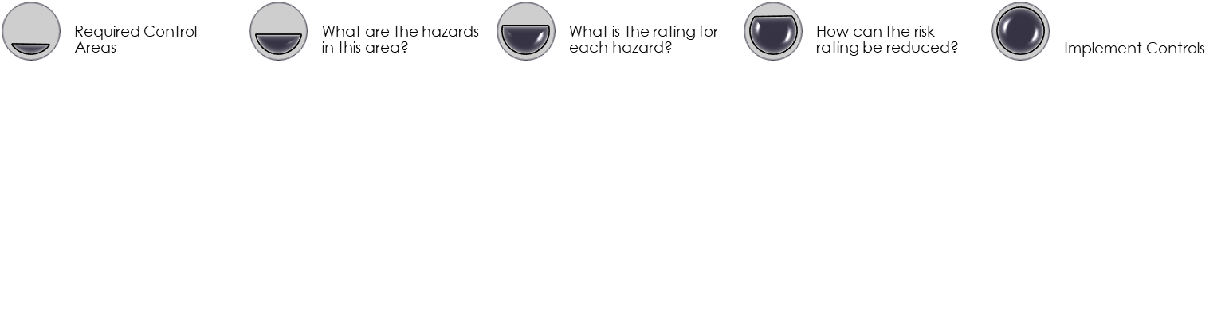

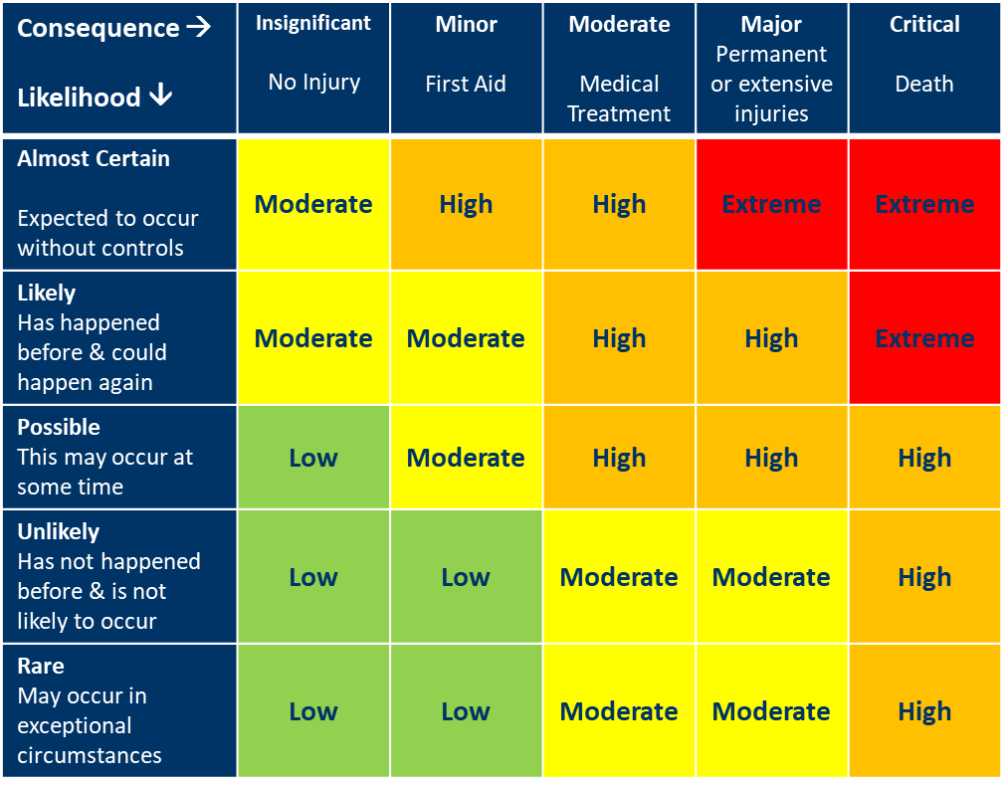

# Risk Assessment & Management Plan

Please add rows and detail to your plan as required to cover all hazards identified

| Hazard Source | Is this Hazard present?  (Yes/No) | Risk Rating?  Low  Moderate  High  Extreme | Risk Management Plan A risk management plan must be completed for Risks rated High or Extreme | Implemented | Communicated | Assessed |
| --- | --- | --- | --- | --- | --- | --- |
| Event Management |  |  |  |  |  |  |
| Access & Parking |  |  |  |  |  |  |
| Gates & Access | Yes | Low |  | X | X | X |
| Roads | Yes | Low | ` | X | X | X |
| Float Parking | Yes | Low | Specified, dedicated, large area of prepared grass for parking floats.  Becomes an issue if there is another horse event scheduled on the main arena | X | X | X |
| Spectator Parking | Yes | Low | Minimal spectator numbers – spectator parking area not specified. | X | X | X |
| Overnight Parking | Yes | Low | Overnight parking in dedicated camping areas. Booked online for the event | X | X | X |
| Stable Access | Yes | Low | Good stable access on sealed surfaces. Entry from either end of the stables. Stables managed by site owner | X | X | X |
| Traffic Management - Vehicles |  |  |  |  |  |  |
| Vehicle routes | Yes | Moderate | Designated roads for vehicles. Multi-directional | X | X | X |
| Speed | Yes | Moderate | Speed signage erected at facility entrance by the event team.  Other site users tend to speed in area past horses. **Block off arena road during events** |  |  |  |
| Judge and official vehicles | Yes | Low | Judges use judging boxes rather than cars, therefore minimal vehicular access.  Separate access point for judges vehicles along edge of arenas if cars need to be brough to the arenas.  Stewards have designated hut, buggies are not used on site | X | X | X |
| Traffic Management – Horses |  |  |  |  |  |  |
| Parking/ stabling to competition route | Yes | Moderate | Horse paths are not specified, and horses can mingle with vehicular traffic to and from parking, warm-up and competition arenas.  **Designate safe horse path with crossings** |  |  |  |
| Horse/ vehicle crossing management | Yes | High | Horse paths are not specified, and horses can mingle with vehicular traffic to and from parking, warm-up and competition arenas.  **Designate safe horse path with crossings** |  |  |  |
| Camping, Stabling and Facilities |  |  |  |  |  |  |
| Camping Areas | Yes | Low | Designated camping areas with dedicated power outlets in place | X | X | X |
| Electricity Access | Yes | Moderate | Designated camping areas with dedicated power outlets in place | X | X | X |
| Stables | Yes | Low | Newly refurbished stables meet biosecurity and safety requirements. Managed by site owner | X | X | X |
| Toilets and Showers | Yes | Low | Adequate toilets and showers. Cleaned daily by site owner | X | X | X |
| Biosecurity |  |  |  |  |  |  |
| Bisosecurity Hazards | Yes | Moderate | PIC codes required as a condition of entry  **Develop and implement biosecurity plan for events in line with FEI guidelines**  **Biosecurity risk prevention plan to be communicated as part of entry conditions** |  |  |  |

| Hazard Source | Is this Hazard present?  (Yes/No) | Risk Rating?  Low  Moderate  High  Extreme | Risk Management Plan A risk management plan must be completed for Risks rated High or Extreme | Implemented | Communicated | Assessed |
| --- | --- | --- | --- | --- | --- | --- |
| Field of Play |  |  |  |  |  |  |
| Surfaces and surrounds |  |  |  |  |  |  |
| Competition area location and condition | Yes | Moderate | Competition area prepared, maintained and assessed by Club Committee prior to each event.  Area closed off to public and other users between competitions | X | X | X |
| Warm-up location and condition | Yes | Moderate | Warm up arenas prepared, maintained, and assessed by Club Committee prior to each event.  One warm-up arena is closed to public use between events. The other is maintained and used by site owner | X | X | X |
| Jumps and other event equipment | No |  | NA |  |  |  |
| Horse Hazards |  |  |  |  |  |  |
| Conditions or actions that could startle horses | Yes | High | **Traffic management plan to be improved**  Competition areas clearly managed with stewards engaged to ensure processes and procedures are met |  |  |  |
| Weather |  |  |  |  |  |  |
| Hot weather | Yes | High | Cold water wash bay available on grounds for cooling horses  Chest freezer available to store ice as required  Adequate cooling for cold water as required  Eskies provided for event officials to ensure that they have adequate hydration. | X | X | X |
| Rain | Yes | High | Grounds monitored and assessed for safety and suitability prior to and during competitions when weather is wet. Competitions cancelled if required  Contingencies put in place when grounds are wet in consultation with stewards and TD – eg entering from inside the arena if grass surrounds are too wet. | X | X | X |

# Emergency Preparedness Plan

|  |  |  |  |
| --- | --- | --- | --- |
| Roles and Responsibilities | Have the roles and responsibilities of the following people in managing risk at the event been documented and communicated?  (yes/ no/ NA) | | Have the roles and responsibilities of the following people in responding to and managing incidents and injuries been documented and communicated  (yes/ no/ NA) |
| Event Organiser | No | | No |
| Officials | No | | No |
| Stewards | No | | No |
| Event Committee | No | | No |
| Technical Delegate | No | | No |
| Ground Jury | No | | No |
| Other – please specify | No | | No |
| Emergency Response | Is there an emergency response plan developed and implemented that includes: | | |
|  | Yes/No | Details | |
| First Aid Providers required | Yes | St John Ambulance contracted to provide first aid at all events | |
| First Aid Equipment onsite | Yes | First aid kit and | |
| Emergency Response Plan | No | TBD | |
| Reporting Processes | Yes | Form 08 – needs better clarity and communication | |
| Concussion Management | Yes | St John provides guidance – needs more | |